Current listing for pet blessings.
These will not be listed in the current newsletter calendar but any new listings will be.

THURSDAY 3rd.

St. Elizabeth Seton 9728 West Palmeras DriveSun City, AZ 85373-2254

FRIDAY 4th.

Our Lady of Grace 18700 N. Saint Gabriel Way, Maricopa, Arizona 85138-3228

Our Lady of Lourdes 19002 N. 128th Ave, Sun City West, AZ 85375

SATURDAY 5th.

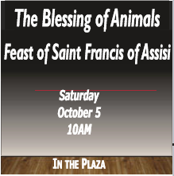
All Saints 1534 N. Recker Rd. Mesa, AZ 85205

Blessed Sacrament 11300 N 64th St Scottsdale, AZ 85254

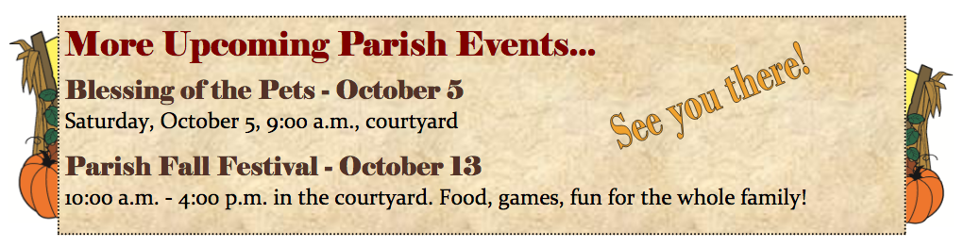
Holy Spirit 1800 E Libra Dr Tempe, AZ 85283

Our Lady of the Valley 3220 W Greenway Rd Phoenix, AZ 85053

St. Francis Xavier 4715 North Central Ave., Phoenix, AZ 85012

St. Helen 5510 W. Cholla St. Glendale, AZ 85304

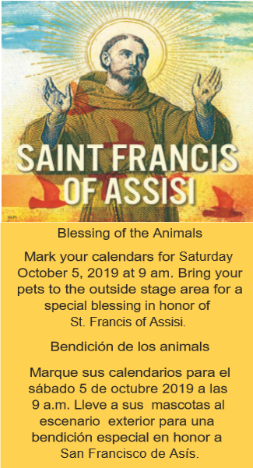
St. Jerome 10815 N 35th Ave Phoenix, AZ 85029

St. Pauls 330 W Coral Gables Dr, Phoenix, AZ 85023

St. Benedict 16223 S. 48th Street, Phoenix, AZ 85048

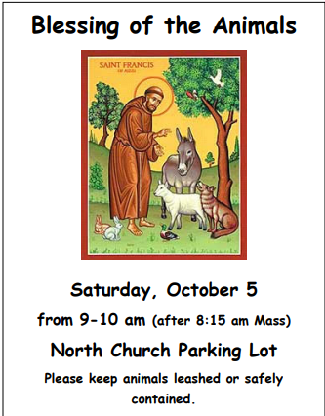

San Francisco de Asis 1600 E Route 66, Flagstaff AZ 86001

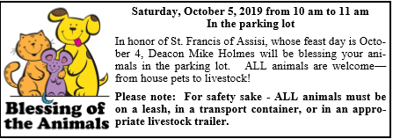

St. Catherine Labouré 2062 N. US Hwy 89, Chino Valley, AZ 86323

Holy Cross 1244 South Power Road Mesa, Arizona 85206

OLPH 5614 West Orangewood Avenue Glendale, AZ 85301-1399

St. Bernadette 16245 N. 60th St. Scottsdale, AZ 85254

Saint Joan of Arc 3801 E. Greenway Rd. Phoenix, AZ 85032-4698

At 10:30AM we have the Blessings of Animals at the Court Yard of the Ascension Hall. Bring your pets on leash or in cages for proper control.

St. Joseph 11001 N. 40th Street Phoenix, AZ 85028

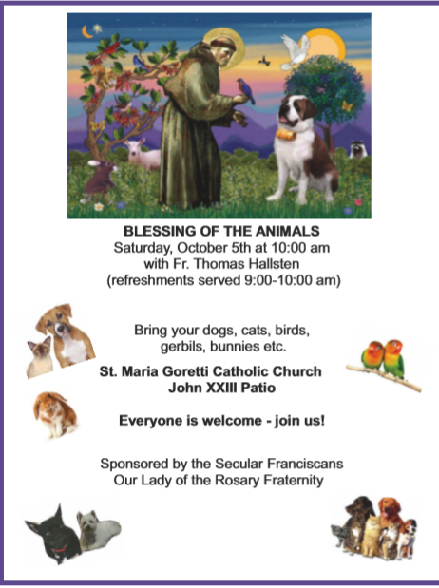
St. Maria Goretti 6261 North Granite Reef Road Scottsdale, AZ 85250

St. Thomas the Apostle 2312 East Campbell Ave., Phoenix, AZ 85016

St. Timothy 1730 W. Guadalupe Road, Mesa, AZ 85202

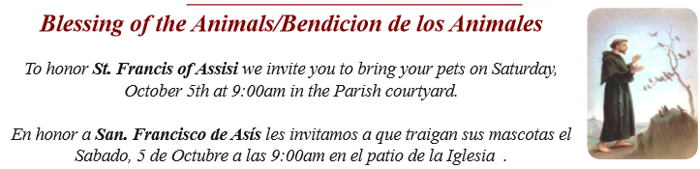
St. Vincent de Paul 3140 N. 51st Ave.,Phoenix, AZ 85031

SUNDAY 6th.

St. Mary’s Basilica 231 N. 3rd Street Phoenix, AZ 85004
https://saintmarysbasilica.org/blessing-of-the-animals/

Corpus Christi 3550 East Knox Road Phoenix, Arizona, 85044

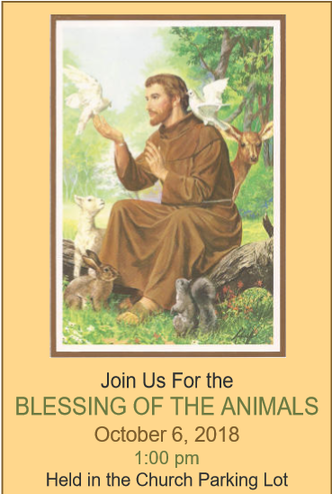
St. Rose Philippine Duchesne 2825 West Rose Canyon Circle Anthem, Arizona 85086

Saint Theresa 5045 E. Thomas Road Phoenix, AZ 85018

SATURDAY 12th.

7655 E Main Street Scottsdale, AZ 85251

